**STEP 1: Identify your Niche**



Fintech is a broad term and has a lot of dimensions to it. The classification of Fintech really depends on various circumstances.

It may refer to a specific set of start-ups and companies, or it may apply to initiatives enabled by technological innovations that contribute to the development of the financial segment.  
 ***There are many domains in fintech to consider, here are some of them:***

***Fund Movement****, or transactions by giving or receiving payments.*

* *Currency*
* *Payment Solution*
* *Remittances*

***Fund Placement*,**or the financing of planned or unplanned financial regulations.

* *Saving*
* *Investing*
* *Borrowing*
* *Alternative Financing*

***Data Management****,*to get insights for improving decision making

* *Financial Management Tools*
* *Research and Data*

For starting a fintech company, one must be crystal clear of the target market and the problem they are looking to address. Besides choosing a domain, your product should cater to a specific audience, e.g., a country, a state, a city or a particular demographic. However, it is always better to launch your startup locally first and expand to the global market later if needed.

**STEP 2: Know the Regulations**



The banking and finance industries are highly regulated ones’ and for obvious reasons. The regulations are why financial service industries can be tough to break into. Several laws have been put to place to ensure that these sectors are protected from frauds. Also, these regulations can immensely vary depending on the country, state or region you want to operate in.

The arrival of Fintech has ushered in new ways of handling and making money, and thus, have created a grey area for regulations. This has been drawing the attention of lawmakers.

So, whatever domain one wishes to venture in, it is of vital importance to thoroughly understand the regulatory measures that apply according to the demographics and geography.

**STEP 3: Discover your Edge**



***Every unique product or innovation that has been able to disrupt a sector successfully has always been the one that has done something differently.***

There couldn’t be a better example for this scenario than Robinhood. With their unique business strategy and viral marketing campaigns, they were able to successfully disrupt the trading and investments domain. Their distinctive business offering, like charging zero commision proved to be an instant hit amongst millennials with limited pocket.

The fintech industry is getting crowded. Many innovations are already underway. Still, a critical entrepreneurial question to ask is if your product/venture will be able to offer something unique and of high importance.

***The danger for startups is to become a “me too.”*** If there is already an entity that is established and doing well in your niche, then you should divert your focus to something new and innovative.

Thus, it is vital for new-age fintech startups to focus their attention towards developing a product that offers a service or a feature that is exclusive to them. There needs to be some sort of nuance that your solution must provide.  
 This distinction would serve as the disruption that you might have been looking for.

**STEP 4: Hire the Right Talent along with the Right Tech Stack**

***• Hiring the right talent***A successful enterprise is made from its people. Therefore, hiring crème-de la-crème from amongst the crowd is of vital importance. If your city has a limited talent pool, then attracting good talent becomes quite tricky.

In such cases, the best decision for a startup would be to hire a software development team offshore (consider India!). This not only cuts significant costs for up-and-coming startups, but also provides a solid team of specialists with specific domain knowledge and relevant experience.

If you are on the lookout for creating a great product and are considering hiring a software development company, then look no further, we have compiled a list of the best financial app development companies.

***• Choosing the right tech stack***It is must for every fintech product to have a customized software. No decent startup relies on *third-party CMSs or frameworks* to handle their transactions. Additionally, no ready-made solution can match the performance capabilities of a custom designed software.

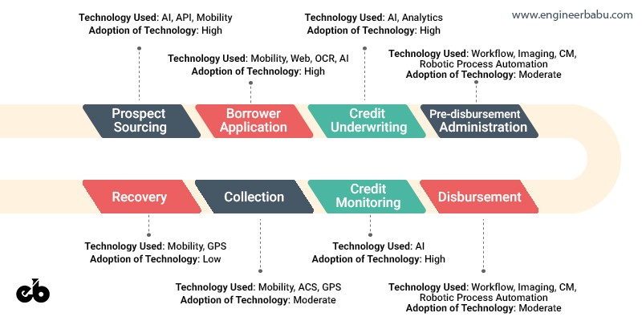

With finance, comes along the risk of data breach. Therefore, **data safety** is one of the most critical aspects of Fintech App Development.   
 Every startup needs to ensure that their product is secure and all the sensitive data is encrypted and stored in the cloud.

**Step 5: Start by creating an MVP (Minimum Viable Product)**

I strongly recommend starting with **a Minimum Viable Product** first.

For beginners,***an MVP is a development technique in which a new product or website is developed with just enough features to suffice for the early users of the product. The final product, with all the elements, is only designed and developed once the feedback is received from the initial users.***

\\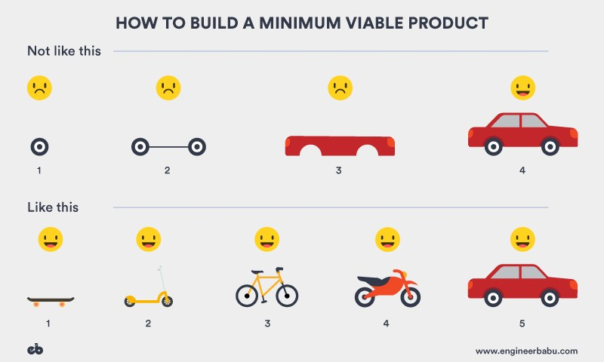

The latter approach is the best practice for building an MVP.

***There are numerous advantages of following this process, primarily:***

**1. Cheaper:**An MVP saves you a considerable amount of investment because you’re not required to develop extra functionalities that may have compromised the product anyway. These cost saving are essential because you don’t know for sure whether the consumers will like the product. Through MVP you can test the waters and then dive into the deeper end of the pool.

**2. Effective:**Using the MVP approach means you end up with only those features that you require the most, so, there is comparatively less façade, and your product turns out cleaner and simpler.  
  **3. Faster:**Another benefit of an MVP is the **Speed of Development**. You’re not trying to create a perfect product right away; it serves as a platform to implement the idea, study its use, make amends and then proceed further. This makes the entire process a whole lot faster and easier.

**4. Reduces risk**: A startup with a Minimum Viable Product is more likely to receive funding from the investors, this is because an MVP gives you an opportunity to test the waters without directly building the final product. It allows developers to test the viability of your product amongst the target audience without requiring huge investments.

***The lower the risk of the investment not paying off, the more likely investors are to fund your idea.***

**Step 6: Get Funded**



Starting a fintech company is a costly affair. Making an incredible product requires talent, and talent isn’t cheap. As traditional organizations are trying to acquire fintech talent for themselves, startups would inevitably face competition in hiring. If your venture isn’t looking to partner with professionals who can create the entire product range, then stay prepared to shell out a reasonable amount for talent.

Now, if you don’t have deep pockets, it becomes quite difficult to stay afloat in this volatile domain. Thus getting an investor onboard becomes essential to not compromise on the product quality.

***What entices Investors?***With the current wave of excitement around fintech. The global venture capital investments have crossed almost **$17B**. This, however, could also be a bane for early age startups, because the competition for funding is snowballing exponentially. VCs are getting more and more selective, and are seeking out companies with ***truly game-changing offerings*.**

Thus, it is required to make your value proposition more and more enticing.

**Step 7: Build Partnerships**

***It is as essential for up-and-coming fintech startups to develop alliances with relevant institutions, as is getting funded.***

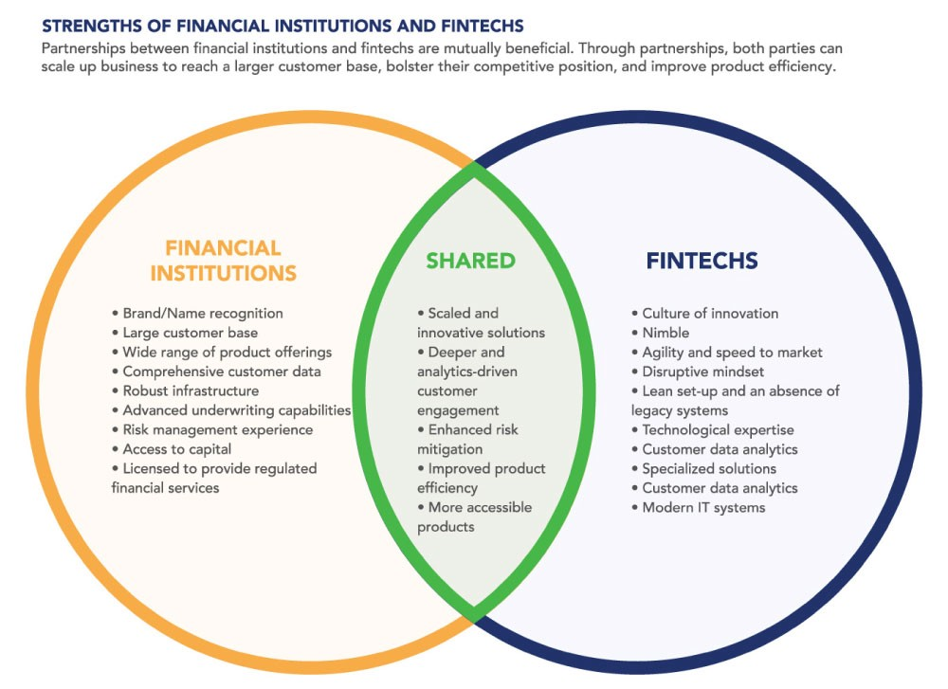

Both Financial Institutions and Fintech Startups can help expand the others outreach by adding a unique element through their collaboration.  
Image Courtesy: centerforfinancialinclusion.org

Partnering is an excellent approach to build muscle in innovation and transformation. In which you can learn at minimal cost and minimum risk. The primary reason for partnering pertaining to this specific domain is, ‘**Credibility**.’

It could be hard for users to trust an emerging entity, and that too in such a volatile domain. Thus, when you are associated with a relevant name, it becomes comparatively easier to sail through those hurdles. Financial institutions also bring along a large customer base and comprehensive customer data.

Thus partnering can provide a considerable boost to startups and together they could improve product efficiency and build highly accessible products.

**Wrapping Up**

Fintech may not be the easiest industry to target. With all the pitfalls in consideration — It takes sweat, time and effort to create a successful fintech company. It demands expertise, creativity, and honestly, a lot of grit to launch a startup in such a frivolous and competitive domain.

There are numerous opinions highlighting the supposed discord between the slow-evolving realm of finance and the highly disrupting world of technology. The pressure on tech companies to deliver huge results rapidly is immense.

*Still,*if you believe that you will be able to solve financial issues for your users through innovative means, go ahead. You will also need the right people by your side. A team with strong technical skills and impeccable domain expertise will definitely help in building something great.

## Steps To Successful Fintech Application Development

Every startup is challenged to outmatch both its immediate competitors and traditional financial institutions. So how to develop a fintech app that will ultimately succeed in such a mission? It might be difficult to know where to start. Don’t worry. We’ve prepared a detailed description of the fintech development process. These clear steps will help you successfully create a fintech app that your users will love. Here’s the way it goes.

### Step 1. Choose Your Niche and Ensure Legal Compliance

The first step is to decide what fintech area will be your focus. There are two ways to go about it. You can either choose the niche and investigate what can be enhanced there, or you can generate ideas and see where they fit among fintech categories. You can always find good investment opportunities if you decide on building mobile apps for fintech.

Once you’ve picked a category, it’s time to ensure that your fintech app will have a sound legal standing. There are countless financial safeguarding systems on the look-out for noncompliance. The most popular examples include the KYC (Know Your Customer) and AML (Anti-Money Laundering) policies. Apart from that, you’ll have to comply with various privacy laws ([GDPR](https://en.wikipedia.org/wiki/General_Data_Protection_Regulation), [CCPA](https://en.wikipedia.org/wiki/California_Consumer_Privacy_Act), etc.) depending on countries where your app will be used. Conforming to the legal requirements is a crucial success factor. So work through this step carefully.

### Step 2. Shape the Concept and Define Feature Set

During this step, you have to think about how to build a fintech app that will have the edge over its competitors. The first task is to perform marketing research. You need to identify your competition and learn what is popular with your target audience.

You should engage skilled Business Analysts and Product Managers who can help you approach this important step efficiently. Together with these specialists, you’ll be able to structure the vision of your solution, develop a solid business case, and define the key features. Such thorough elaboration at this stage will help to cut the cost to build a fintech app and reduce time to market in the long run.

### Step 3. Design Compelling UI/UX

The main question that should be answered at this point is how to make a fintech app user-friendly and easy-to-use. The UI of your app is its business card. So it should grab the eye at a single glance and make your brand recognizable. Through collaboration with experienced UI/UX designers, you will tackle this challenge with ease. By creating interactive prototypes, the UI/UX professionals can design an engaging and intuitive user experience for your app.

### Step 4. Choose the Development Approach and Estimate Time & Costs

How to determine the cost to build a fintech app? What development approach to use? How to create a fintech app prototype? All these points should be accounted for during this stage. To deal with this task, you should collaborate with a seasoned Project Manager. The development and QA experts should take part in this process as well to identify the tech stack and implementation constraints. As a result, you should have a robust development plan that will balance your budget and time constraints.

### Step 5. Develop MVP and Get Your Idea Confirmed In Practice

Before launching a long-term project, it’s good to test out your idea first. A minimum viable product (MVP) version serves this purpose. An MVP is a proof of concept that includes just enough features for the first users to try it out. It helps make sure that you will create a fintech app that brings value to its users. Also, it is a great way to market your app and attract investors. With an MVP, you get early feedback, thus minimizing the risk of your idea not paying off.

### Step 6. Ongoing Development, Releases, and Support

The development process does not stop after your app is launched. It’s time to keep improving and upgrading as you start getting valuable feedback. At HuskyJam, we have vast experience of ongoing development and support of complex fintech solutions. So you can trust us with continuous enhancement, timely releases, and support. Together we can develop a fintech solution that will be difficult to compete with.

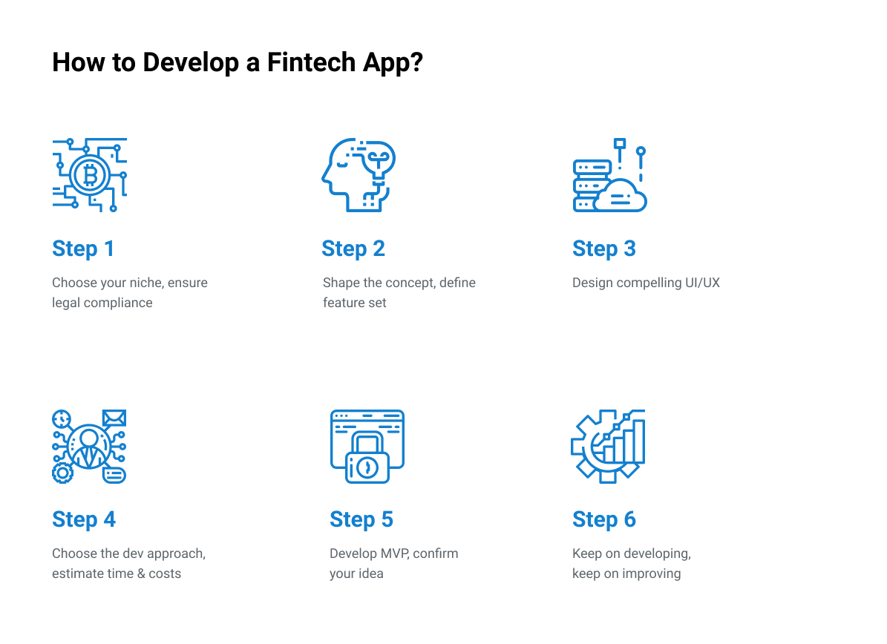

## How Much Does it Cost to Build a Fintech App?

We’ve already covered the essential trends, technologies, and features. Now let’s talk about the cost to build a fintech app. The total price depends on a number of factors. The hourly rate of your development team, the number of features, as well as their complexity, contribute to the total budget.

The hourly rates differ from country to country. The rates of the main development regions are as follows:

* The USA - $120-150
* Western Europe - $50-100
* Eastern Europe - $35-40
* APAC - $25-40

The below table provides pricing for each development stage for a basic fintech app. The final cost can be lower or higher depending on your particular project and its goals.

| **Project Stage** | **Hours** | **Cost** |
| --- | --- | --- |
| Discovery (shaping the concept through business analysis) | 40 hours and more | $4 000 and higher |
| UI/UX Design | 40 hours and more | $4 000 and higher |
| Frontend development | 1 month and more | $16 000 and higher |
| Backend development | 2 months and more | $32 000 and higher |
| Mobile app development | 2 months and more per platform (iOS/Android) | $64 000 and higher |
| Quality Assurance | 80 hours and more | $8 000 and higher |
| Post-launch support | on-demand/ongoing | $75 per hour |
| **TOTAL:** | | $130,000 |

## Crucial Features for Fintech Apps

When you brainstorm ideas for your fintech app, you should focus on identifying and solving a significant issue for your target users. You don’t necessarily need to come up with something brand-new. You can determine how to make a fintech app that could do something better, cheaper, or with fewer clicks than other solutions of the kind. No matter what ultimate goal you set, there are features that each good fintech app should include. Here they are:

* The **sign-in** flow should be **simple but secure**. A win-win solution is to integrate voice and face recognition and fingerprint authentication along with good old two-factor authentication. Biometrics will soon be an obligatory feature. For instance, starting from iOS 13, Apple requires all apps using social login services to support the Sign in with Apple feature that utilizes in-built iOS biometric capabilities.
* Your app should offer **basic financial operations** relevant to your fintech branch. This may include digital payments, money transfers, mobile depositing, or balance checking. Your users should be able to perform as many operations as possible without the need to turn to the web application or a brick-and-mortar institution.
* If your app includes **QR code and card number scanning**, the life of your users will be way easier. Scanning a card for a card number instead of manually entering all the digits is a significant advantage for your users. The same goes for QR code scanning. So when pondering how to develop a fintech app that can alleviate pain points of the users, don’t forget about this feature.
* Not all fintech apps take care of **personal finance management**. When thinking about how to build a fintech app that would make a difference, include tracking features for budgeting and savings. Besides, the users will definitely like it if they can manage different accounts in one place.
* **Custom notifications** are a crucial feature for engaging user experience. When it comes to lifestyle, everyone likes personalization. Let your users choose which information to receive and when, be it regular transfers or personalized offers.
* **Cashback** is another feature important for user engagement. Your users will enjoy your app even more if they can benefit from purchases performed through it. When determining how to make a fintech app that will have high retention rates, consider a loyalty program feature. You can offer users a higher percentage of cash back if they spend more money via your app.
* You can include **unconventional financial services** into your app, like ordering food, buying tickets, or giving money to charity. This will allow people to manage their finances in one secure place. This guarantees a positive user experience.
* **AI-powered chatbots and virtual assistants** play an essential role in customer engagement when developing fintech solutions. They can answer tons of questions to hundreds of customers simultaneously. So your users can get assistance anytime they need. At the same time, these tools can considerably reduce the load on your customer contact centers. As they can resolve simple issues quickly allowing your team to focus on more complex queries. However, keep in mind that these benefits evaluate to true only when these modules are developed, trained, and tested carefully.

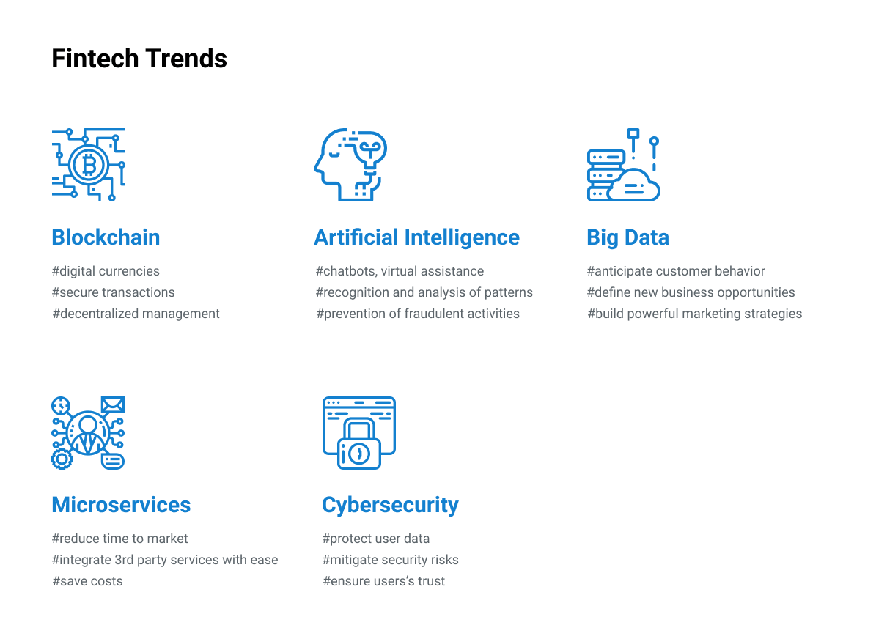

## Technology Stack Trends and Challenges in Fintech App Development

To create a successful fintech app, you should match your business objectives with the right technology stack. It’s also important to know what’s what regarding the major technology trends. When undertaking a fintech development project, take into account the five innovative trends listed below.

* **Blockchain** is a series of time-stamped blocks of unchangeable data. Once a new block is linked to the chain, its data can’t be modified or deleted. A decentralized approach to data storing takes care of data security. These capabilities make blockchain a highly reliable technology to use in fintech for transparent data transfer and transaction recording. So if you’ve been wondering how your app could ensure transparent and trustful relationships between the users, blockchain technologies could be the answer.
* **Artificial Intelligence** employs neural networks that are designed to recognize and analyze patterns in the input data. AI proves to be an effective tool for interpreting and recommending actions based on the analysis of real-time data streams. It makes AI applicable to a full range of fintech challenges. For instance, the development of financial advising services or the detection of fraudulent activities. So AI is the solution to the question of how to build a fintech app that’s sharp and reliable.
* **Big data** is collected from electronic devices of all kinds. Every day 2,5 quintillion data is produced and gathered. With data analytics, this heap of information can provide invaluable insights into business development opportunities. Big data helps deal with the issue of how to create a fintech app that’ll become the only go-to option for its users. With big data, you can anticipate customer behavior and build powerful marketing strategies.
* **Microservices** are a way to structure an application as a set of interrelated services. In this way, fintech apps turn into distributed systems with decentralized management of data. Solution development becomes faster, as you can simply integrate any required service into your infrastructure. Besides, microservices go hand in hand with blockchain and AI. So following this trend is an important strategic step to reduce the cost to build a fintech app.
* **Cybersecurity** is an all-time concern of the digital world. Particularly for the fintech apps that store and process sensitive customer data. To mitigate the risks of security breaches and data theft, financial companies should employ various security techniques. Among them are penetration testing, Static Application Security Testing (SAST), Dynamic Application Security Testing (DAST), Runtime Analysis, Automated Regression Testing, Source Code Analysis (SCA), and innovative DevSecOps methodologies. The below table lists the most common threats and risks along with recommendations you can follow to build fintech apps that are more reliable and secure.

|  |  |
| --- | --- |
| **Risks and Threats** | **Countermeasures** |
| Data Leakage/Loss | * Data encryption and classification based on its level of sensitivity (restricted data, private data, public data) * Access policies for defining which employees can access which data * Data leakage/loss prevention (DLP) features like inspection of data being sent, disabling of Universal Serial Bus (USB) and CD drives in laptops and desktops, and more. * Robust backup systems including cold backup |
| Digital Identity Theft | * Two-factor authentication * Biometrics authentication * Strong password policies * Single sign-on (SSO) solutions * Credit monitoring and identity monitoring features |
| Malware Attacks | * URL filtering to block malicious links that may contain malware * Content Disarm and Reconstruction (CDR) modules * Firewalls with Deep Packet Inspection (DPI) and malware scanners * Sandbox-driven email gateway servers * Solutions for prevention from Distributed Denial of Service (DDoS) * Antivirus solutions with up-to-date databases * AI and machine learning for malware pattern recognition in software |
| Compromise of Cloud Environment | * Avoiding public clouds, performing a risk assessment of the cloud service provider * Introducing cloud governance policies * Setting up database honeypots * Setting up Software Defined Perimeter (SDP) |
| Compromise of APIs | * API token rotation * API access identification, authentication, and authorization * API quotas and throttling * API gateways for traffic inspection |

| **Language** | **Tasks** | **Pros / Cons** | **Fintech Libs** |
| --- | --- | --- | --- |
| Java | - Big data processing  - Tolerance of heavy loads  - Web-oriented development | **Pros:** - Security - High portability due to the Java Virtual Machine entity  **Cons:** - Complex and verbose code - Memory is managed via the garbage collector that affects performance | - [Strata](https://github.com/OpenGamma/Strata): analytics and market risk  - [killbill](https://github.com/killbill/killbill" \t "_blank): subscription billing and payments |
| Python | - AI- and machine learning-related tasks  - Cost- and time-efficient cryptocurrency development due to a wide range of ready cryptocurrency solutions  - Web-oriented development | **Pros:** - Simple and concise code - Powerful frameworks  **Cons:** - Not suitable for mobile development - Not suitable for memory-intensive tasks | - [PyAlgoTrade](https://gbeced.github.io/pyalgotrade/" \t "_blank), [Zipline](https://www.zipline.io/): algorithmic trading libraries  - [ffn](https://pypi.org/project/ffn/" \t "_blank): financial functions for quantitative finance  - [PyRisk](https://pypi.org/project/PyRisk/" \t "_blank): financial risk and performance  - [Pybitcointools](https://pypi.org/project/pybitcointools/" \t "_blank): commonsense Bitcoin-themed Python ECC library |
| C# | - Windows-oriented development  - Web-oriented development | **Pros:** - Strong memory backup prevents memory leaks - Type safety  **Cons:** - C# applications run slowly - Dependency on the .NET framework | - [Financial-Formulas-Library](https://github.com/srbrettle/Financial-Formulas-Library-.NET-Standard): A collection of methods for solving Finance/Accounting equations  - [Excel Financial Functions](https://github.com/fsprojects/ExcelFinancialFunctions): the full set of financial functions from Excel |
| C++ | - When high execution speed is required  - Development of resource-constrained applications | **Pros:** - High speed - C++ portability features allow writing the code once and then compile it for different platforms  **Cons:** - Complex code - Requires highly skilled developers as due to C++ complexity it’s difficult to write secure code | - [QuantLib](https://github.com/lballabio/QuantLib" \t "_blank): quantitative finance  - [Armadillo](http://arma.sourceforge.net/): linear algebra and scientific computing |
| Ruby | - Sophisticated web-application development | **Pros:** - Powerful frameworks - Time- and cost-efficient  **Cons:** - Low boot speed | - [finance](https://github.com/marksweston/finance): financial calculations  - [money](https://github.com/RubyMoney/money): money and currency conversion |

After deciding on which trends to follow, it’s time to choose the technologies stack. It’s a critical step as these technologies will set the constraints for implementing your app. The right tech stack should help you to create a fintech app that’s easy to maintain and upgrade.

For frontend development, JavaScript with the Vue.js and React.js frameworks and Python with Django or Flask are among the most popular technologies. Python, Java, Scala, and Golang are solid options for backend development. When building mobile apps for fintech, Swift is used for iOS, while Android requires Kotlin. If you’d like to have a cross-platform app, then React Native and Flutter are two good options.

There are lots of programming languages to choose from. It’s needless to mention that each of them has its own advantages and drawbacks. To choose the right one for your project, you have to evaluate your long-term goals and expectations. By selecting suitable technologies for your tasks, you can shorten time to market and reduce the cost to build a fintech app. So you’ll most likely need to employ different languages for different project parts to build a fintech app that will achieve the best results.

In the below table, you can find a list of the languages popular in the fintech industry along with their pros and cons.

## Types of Fintech Apps

To start building mobile apps for fintech, it’s important to get up to speed on the various branches of fintech that are out there. To determine how to make a fintech app successful, it’s vital to choose the right development direction for it. To help you with these tasks, we’ve listed the main categories of fintech apps. It will give you valuable insight into the current fintech market trends.

### Digital Payments

Digital payments form the largest branch of the fintech industry. According to Statista, the total value of digital payments worldwide amounts to US$4,769,370m in 2020. Digital payments address the need for cashless, fast, and secure money transfers. Such solutions as online payment systems, digital currencies, and e-wallets help to cover this need. By taking a look at the following popular platforms, you can get an idea of how to develop a fintech app that deals with digital payments.

* [**PayPal**](https://www.paypal.com/) is a digital payment platform. It enables secure transactions between customers and vendors without disclosing their financial details. PayPal supports a wide range of credit and debit cards that you can register with your PayPal account.
* [**Payoneer**](https://payoneer.com/) is an online payment system that enables domestic and cross-border money transfers. For financial transactions, you need to use a prepaid Mastercard. Being integrated into many freelancing platforms, Payoneer is quite popular with freelancers.

### Digital Banking

Digital banking has become the go-to option for customers who need to manage their bank accounts and perform financial transactions quickly and without third-party help. To address these needs, online, mobile, and digital-only banks have emerged. To withstand a growing competition in this sector, traditional banks had to build fintech apps for their customers as well. The N26 and Revolut banks are an excellent example of how to build a fintech app in the digital banking domain.

* [**N26**](https://n26.com/) is a digital bank that provides fully digital accounts that can be managed through the N26 mobile app. You can also use an N26 contactless debit card. N26 allows you to pair your account only with one smartphone at a time. You have to confirm all online and offline transactions with your PIN.
* [**Revolut**](https://www.revolut.com/) is a digital bank that is aimed at global spendings. With Revolut, you can use your existing bank account to convert deposited funds into various currencies. Revolut enables free international money transfers, fee-free global purchasing, and access to the cryptocurrency exchange.

### Digital Lending

Digital lending has transformed the process of originating and renewing loans. From simple loan apps and websites to comprehensive automated platforms, digital lending software enables efficient handling of loan requests and effective interaction between lenders and borrowers. So both independent digital lenders and traditional financial institutions make use of fintech advances to improve their business. The following solutions can serve as a guideline on how to create a fintech app for digital lending.

* [**Kabbage**](https://www.kabbage.com/) is a digital lending app that provides lines of credit and payment services to businesses. Kabbage has no score requirements and doesn’t require extra fees. Business owners can easily apply for a loan, get a decision about their fees and rates, and start using funds in several minutes.
* [**Calyx Point**](https://www.calyxsoftware.com/) is a provider of mortgage solutions for banks, mortgage lenders, brokers, and credit unions. It is designed to simplify and optimize all phases of the loan process.

### Digital Investment

Digital investment platforms allow retail and institutional investors to investigate and to invest in different financial assets. Investment apps are a perfect opportunity to get started on the stock market. Investment management solutions enable users to enhance their investment performance by supplying them with relevant analytics and data. If you’d like to create a fintech app for digital investments, you can check out the following solutions for ideas.

* [**Hedgeable**](https://www.hedgeable.com/) is a robo-advisor that provides wealth management capabilities for investors. It offers automated investing with lots of customization options and features. With no minimum account requirements, Hedgeable charges annual fees based on the amount in the investor’s account.
* [**Addepar**](https://www.addepar.com/) is an investment management solution for advisors and investors. By handling various types of assets in any currency, it’s aimed at the global financial system. Using Addepar, business managers can get a clear financial picture to communicate financial decisions in an efficient way.

### Insurtech

Digital insurance, or insurtech, deals with technologies used in the insurance industry. Its main goal is to speed up policy administration and claims processing. Insurtech also helps to reduce the likelihood of fraudulent activities in insurance claims. Insurtech solutions vary from basic websites offering insurance for just an hour for someone borrowing a car to complex CRM systems. If you consider building mobile apps for fintech in the insurance sector, have a look at the below solutions for inspiration.

* [**BIMA**](http://www.bimamobile.com/) is a provider of mobile-delivered insurance. It partners with mobile network operators and financial businesses to supply millions of low-income people with insurance and underwriting. BIMA provides life, personal accident, and health microinsurance options.
* [**Trōv**](https://www.trov.com/) is an on-demand insurance app that enables users to insure single property items for any period of time entirely from their smartphones. Trōv also allows people to store important information about their property in the Trōv app and back it up to the cloud account.

### Regtech

Regtech is aimed at solving regulatory issues and challenges by employing innovative technologies. Regtech solutions enable companies to closely observe the ongoing processes and carry out analyses to ensure compliance with regulatory requirements. By automating business processes, regtech also helps to minimize the risk of human error. The following solutions are great examples of regtech apps.

* [**6clicks**](https://6clicks.io/) is a global risk assessment and compliance platform. It helps to automate and manage risk identification, assessment, and reviews for all stakeholders of the risk management lifecycle.
* [**PassFort**](https://www.passfort.com/) is a compliance platform that allows automating KYC, KYB, AML, and other compliance checks. It enables you to translate compliance policies and processes into digital, automated onboarding tasks.

### Consumer Finance

The consumer finance branch provides users with assistance in the management of their expenses. Using fintech apps of this type, the users can plan their spendings in advance. Then the future account balances can be forecasted to prevent the user from spending more than planned. Checking out the following solutions will give you an idea about how to develop a fintech app for the management of consumer finances.

* [**Mint**](https://www.mint.com/) is a free budgeting app that assists users with keeping track of their incoming and outgoing money. This app can be synced with various credit cards, PayPal, and bank accounts.
* [**MoneyPatrol**](https://www.moneypatrol.com/) is a personal finance tool that securely monitors user financial accounts. With this app, you can easily oversee your spendings across all of your auto-bucketed categories.